Design Pattern 2 – Command Pattern

This pattern consists of using a class as a command, this can be beneficial for executing and initializing a set of actions. With a command class you can manipulate these commands from the invoker. Commands can be saved , reversed, or executed in an order.

**Code Snippet**

**Structure**

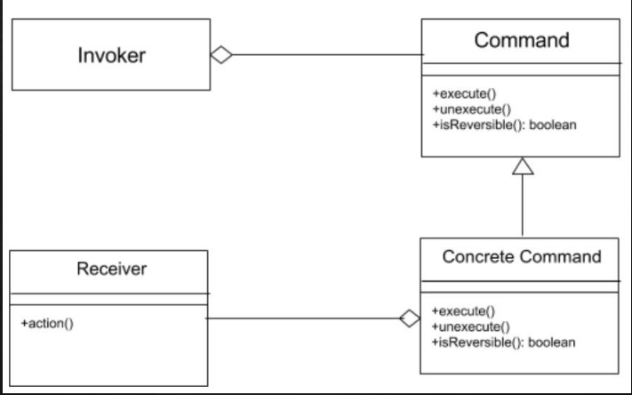

**Code Location**

The pattern is found in various destinations. The command interface is found in the following path:

*“de/saxsys/mvvmfx/utils/commands/Command.java”*

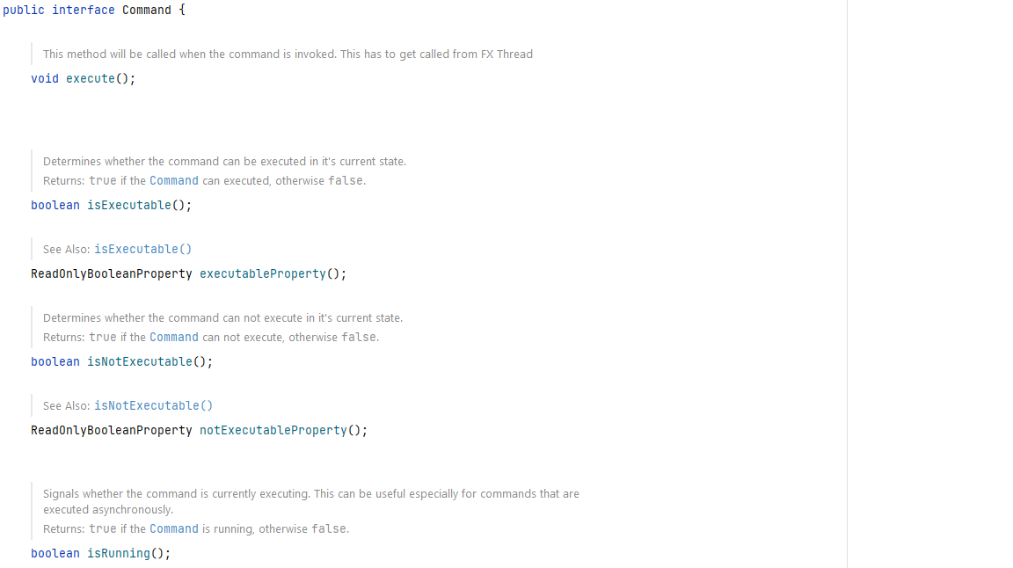

After some extends and implements, the concrete command class called NewEntryAction that has the following path:

*“src\main\java\org\jabref\gui\importer\NewEntryAction.java”*





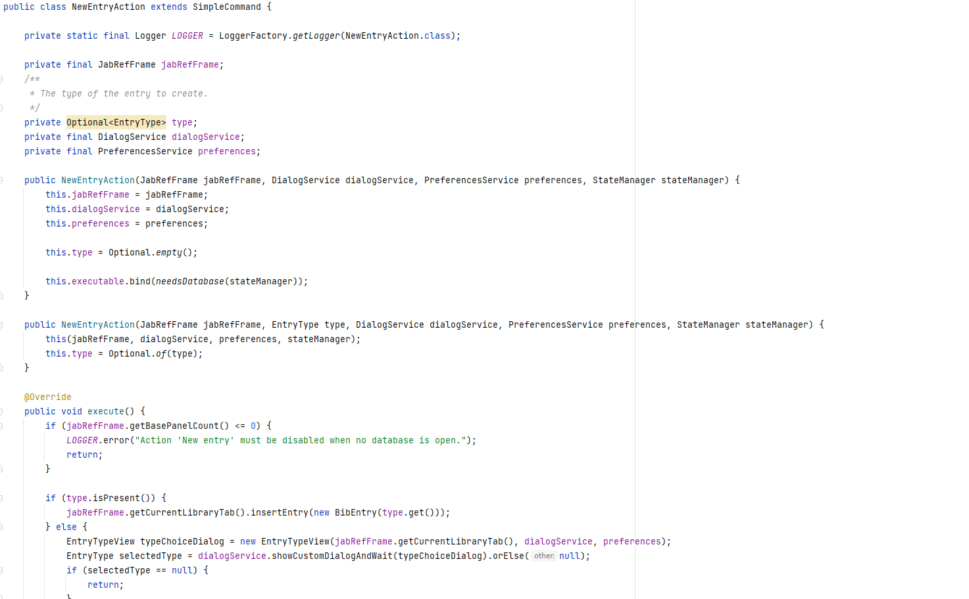

The final class is the invoker class, that it is called JabRefFrame. JabRefFrame has the following path:

*“src/main/java/org/jabref/gui/JabRefFrame.java”*

**Justification**

As shown above, the command pattern is being used because the project has a concrete command class called NewEntryAction that ends up implementing the command interface. The interface and the class NewEntryAction have all the method that a command pattern has, and the invoker(JabRefFrame) manipulates the command by creating a new one and executing it.